Use cases

Manage user

Manage posts

Manage conversation

Manage reports

Requirements covered:

|  |  |
| --- | --- |
| Use case: | Requirements: |
| Manage user | 1,9,14,15,16,18,19 |
| Manage posts | 2,4,5,6,10,11,12,13,17,20,21 |
| Manage conversation | 3,6,7 |
| Manage reports | 8,10 |

Use case diagram

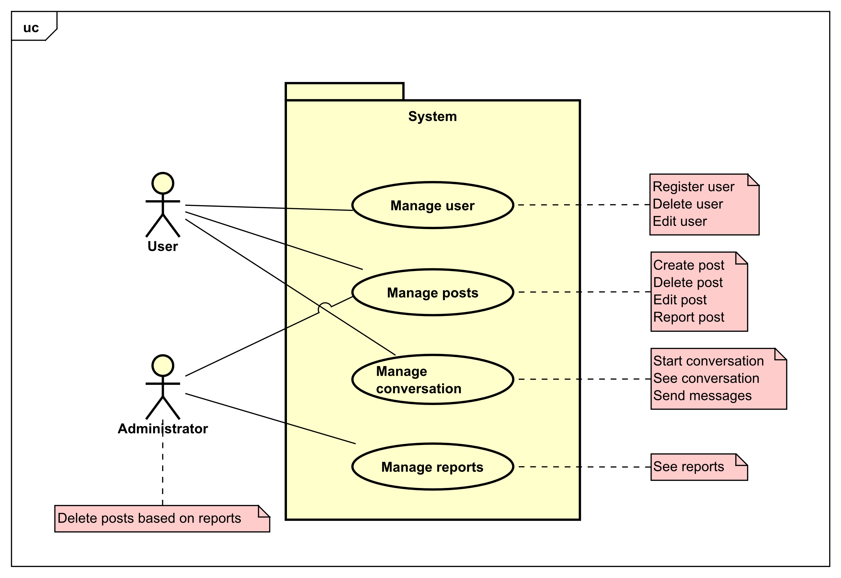

Use cases – Brief Description

**Manage user** – A user enters the website for the first time and would like to buy something. The user would be able to search and message sellers at free will. If the user wants to also sell something on the website, the user will have to go through a registering process and soon after will be able to also sell items on the website. The next time the user enters the website, would likely login into his account. The user may also like to change his name due to a small typo; the user will go to his profile and start editing. If the user cannot login due to an incorrect password, he will access the forgotten password function of the system and change his password.

**Manage posts** – A user will need an account to access most of the functions. The user presses the new post button and starts introducing all the necessary information required to create a post. Another user logs on to the website, sees the post and starts talking to the seller. The user ends up buying the product, and goes to the seller’s profile, writes a nice comment, and gives the seller a positive rating. Now the seller goes to his post marks it as SOLD or deletes the post entirely so that he won’t be contacted again for a product he sold.

**Manage conversation** – A user sees an item, decides to buy the item and messages the seller. Afterwards they have a conversation about the item, and important information about the product and price and plan to meet up. The user looks on the chat again, finds the address in the chat and goes there.

**Manage reports** – A user finds on the website an item that is against the rules of prohibited items and reports the post. The administrator receives the report, looks up the post and deletes the post if the report was true.

Use Cases – Fully Dressed Description

|  |  |
| --- | --- |
| Use case | Manage user |
| Summary | Use case description for managing users. |
| Actor | User |
| Precondition | The user must exist in the database. |
| Postcondition | The information about the user is stored into a database. |
| Basic Scenario | Manage User   1. User presses the login button 2. A window will be shown with the necessary information that should be completed in order to get into the account. 3. When the user is logged in, a profile button will be shown. 4. If user want to edit his profile, he/her should press the profile button. 5. A window will be shown, where the user can edit his profile. |
| Alternative Scenario |  |
| Exception | If one of the fields or more are empty, an error will be shown. |

|  |  |
| --- | --- |
| Use case | Manage posts |
| Summary | Use case description for managing posts. |
| Actor | User |
| Precondition | The user must be logged in, and to have at least one post. |
| Postcondition | The details and information for the post will be saved into a database. |
| Basic Scenario | Manage Posts   1. User logins to his account. 2. User presses the marketplace button. 3. A window will be shown with all items that are for sale and their description. 4. If the user wants to sell an item, he needs to press the add post button. 5. A window will be shown, where the user can add all the necessary information about the item or edit it.   Delete Posts   1. Users can delete the post by pressing the edit button. 2. A window will appear will all the information about post, and a delete button below. 3. The user presses the delete button and the post will be deleted. |
| Alternative Scenario |  |
| Exception | If one of the fields or more are empty, an error will be shown. |

|  |  |
| --- | --- |
| Use case | Manage conversation |
| Summary | Use case description for managing conversation. |
| Actor | User |
| Precondition | The user must be logged in. |
| Postcondition | The conversations are saved into a database. |
| Basic Scenario | Manage Conversation   1. User logins to his account. 2. User presses the messages button. 3. A window will be shown with all the conversations that the user has. 4. If the user wants to message a seller, he just presses the contact seller button below the post. 5. The user will be redirected to messages where he can write to the   Delete Conversations   1. User chooses the conversation. 2. A window will appear with the conversation 3. The user presses the delete button and the conversation will be deleted. |
| Alternative Scenario | The seller can also delete the conversation. |
| Exception |  |

|  |  |
| --- | --- |
| Use case | Manage reports |
| Summary | Use case description for managing reports. |
| Actor | Administrator |
| Precondition | The administrator must be logged in. |
| Postcondition | The reported post will be deleted from database |
| Basic Scenario | Manage Reports   1. Administrator enters his account. 2. Administrator can press the report button. 3. A window will be shown with all the reports the users gave. 4. If the administrator finds the post harmful, he can delete it by pressing the delete button. 5. The post will be deleted from the marketplace and database. |
| Alternative Scenario |  |
| Exception |  |